Design Form

Choose Your Collar
Specific Pantone Number:

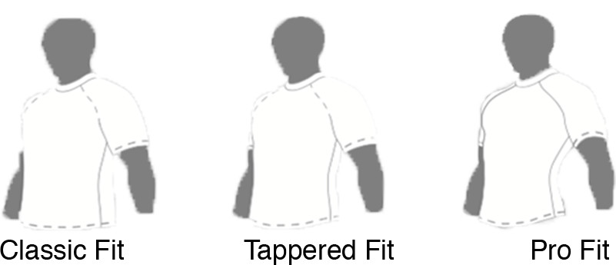
Choose Your Fit
Specific Pantone Number:

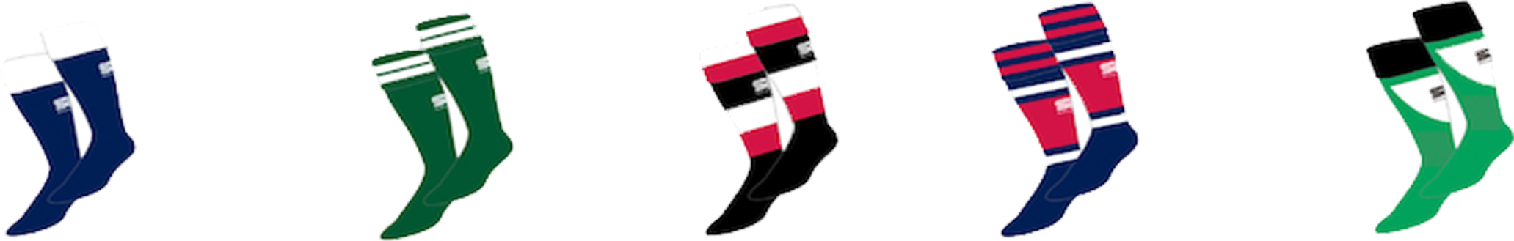
Choose Your Sock Design
Specific Pantone Number:

Shorts
Specific Pantone Number:
